"""

Loan_ID: A unique loan ID.

Gender: Either male or female.

Married: Weather Married(yes) or Not Married(No).

Dependents: Number of persons depending on the client.

Education: Applicant Education(Graduate or Undergraduate).

Self_Employed: Self-employed (Yes/No).

ApplicantIncome: Applicant income.

CoapplicantIncome: Co-applicant income.

LoanAmount: Loan amount in thousands.

Loan_Amount_Term: Terms of the loan in months.

Credit_History: Credit history meets guidelines.

Property_Area: Applicants are living either Urban, Semi-Urban or Rural.

Loan_Status: Loan approved (Y/N). # target variable

"""

df[df['Gender'] == 'M']['LoanAmount'].mean()

# Property_Area wise median value of Income

# Property_Area wise max value of loan

# median of income and max of loan amount

"""

property_Type max

urb

se

ru

"""

df[df.group_by('Property_Area')]['ApplicantIncome'].median()

# create a new column which is percentage of loanamount to annual_income

def getPercentage(loanamount, annual_income):

return loanamount / annual_income

df['percentage'] = df.apply(getPercentage, df[['loanamount', 'annual_income'])

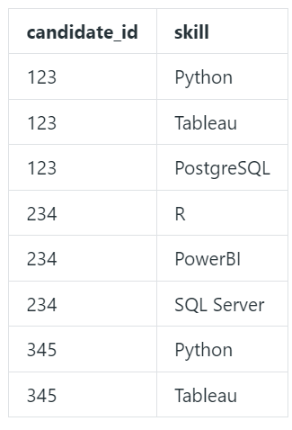

# get candidate IDs who have all python tableau and postgresql skills

SELECT candidate_id FROM (SELECT * tablename WHERE skill in ('Python', 'Tableau', 'PostgreSQL')) agg=GROUPBY(COUNT) candidate_id WHERE agg = 3;

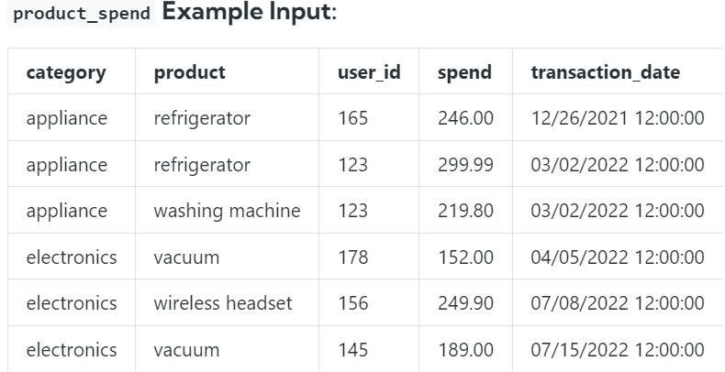

# for 2023, get max prices for each category

SELECT MAX(spend) FROM tablename WHERE transaction_date[5:10] = '2023' GROUPBY category;